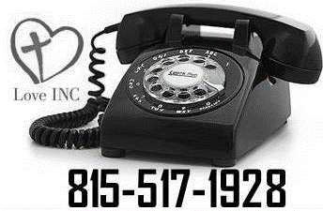
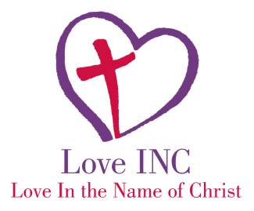
Items
NEEDED for Ministry
to bring HOPE & ENCOUARGEMENT
February

Lamp Ministry
-Love In the Name of Christ-
- Lamps
- Light bulbs
- Shades

Dining Tables
Love INC
- 4-6 person tables
- dining chairs

Diaper needs
-Love INC-
- All sizes of diapers
- baby wipes

- Our average client’s household income is $831
- Volunteers from multiple churches use the donated items to connect with those in need. The desire is to see one become involved in their church if they are already not attending somewhere.

“We value transformation in the lives of people and communities.”

Upcoming FUNDRAISERS…..Give DeKalb County
May 6th Please keep us in mind for this day of giving.
Facebook: Love INC of DeKalb/Sycamore
Website: www.loveincdeksyc.org
email: loveincdk@gmail.com
phone: 815-517-1928

