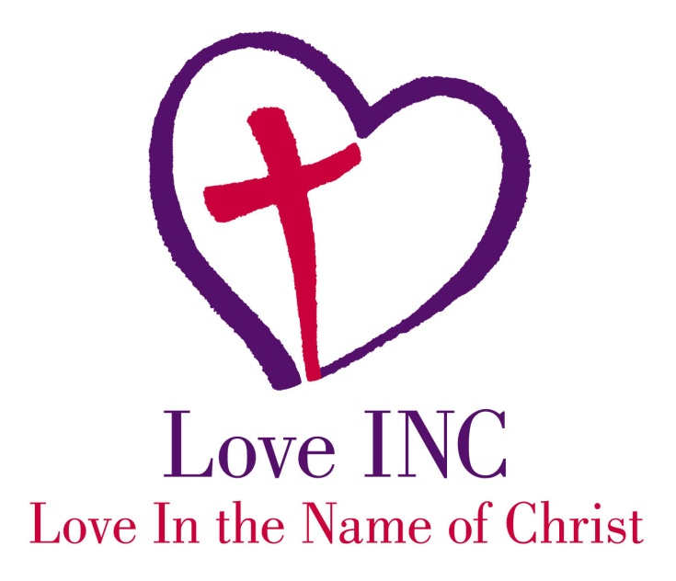
2,040 people impacted
2,390 needs met
815-517-1928
Facebook: Love INC of DeKalb/Sycamore
Website: is coming
DeKalb-Sycamore
471 Volunteers
$804 was average monthly income of our clients
28 Gap Ministries (programs to help the needy)
18,412 volunteer hours of service to our community
Assisted 86 homeless families in their transition to their own place
21 individuals were part of our Community Service Interaction gap ministry. They were court appointed or school required community service hours.
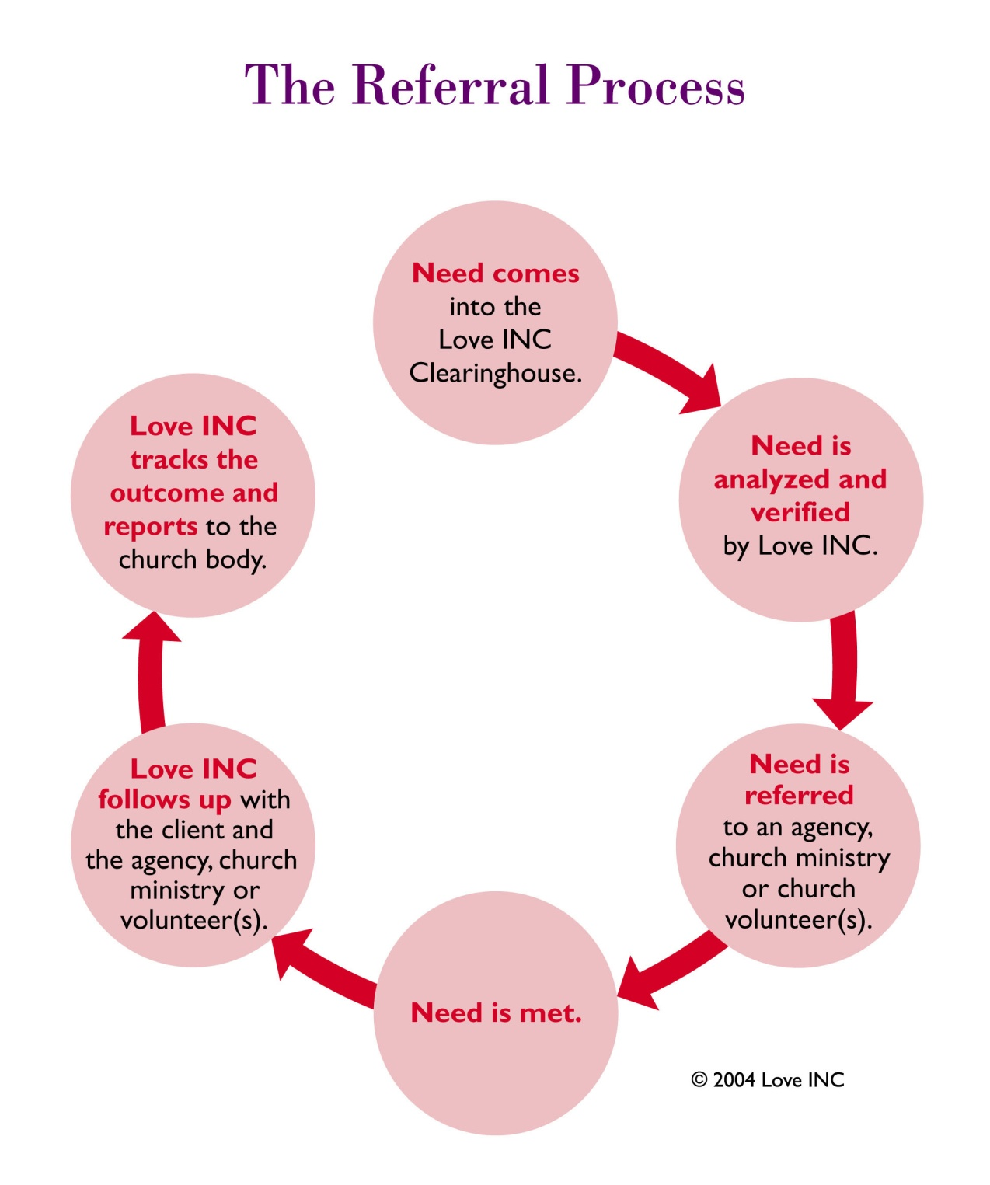

This process has shown to be effective. We are not an emergency need meeting organization as we take precautions to protect the resources of the church. We don’t want to just meet the need, but build a relationship (client and the church) to be a positive support base for the client during their time of difficulty. We want to encourage them as they take steps to rise out of poverty. Poverty has been categorized in different types for instance: Generational Poverty, Chronic Poverty, and Genuine Poverty. At times the best thing we can do for an individual is say, “no.” If our national mission statement says, “we exist to transform lives and communities” the best thing to do at times to move towards our existent statement is to say no. We receive calls from all three of the above categories. We desire to assist and give tools to all to help them rise out of poverty. Tools will vary.

